CALL

MAIN MATRIX
S₀ = 100 | Time = 1 | Sigma = 0.02 | Lamda = 1.22474 | Risk free = 0.05
Number of iterations | CRR | KR | DiffCRR | DiffKR
 |  | K = 90 | BS = 16,6994
5 | 16,5590 | 16,6374 | 0,1404 | 0,0621
10 | 16,7222 | 16,7419 | -0,0227 | -0,0425
20 | 16,7006 | 16,6901 | -0,0012 | 0,0093
40 | 16,7252 | 16,7081 | -0,0258 | -0,0086
60 | 16,6818 | 16,7061 | 0,0176 | -0,0066
80 | 16,7119 | 16,7000 | -0,0125 | -0,0006
100 | 16,7105 | 16,7030 | -0,0110 | -0,0035
 |  | K = 100 | BS = 10,4506
5 | 10,8059 | 10,3320 | -0,3554 | 0,1185
10 | 10,2534 | 10,3887 | 0,1972 | 0,0618
20 | 10,3513 | 10,4192 | 0,0993 | 0,0314
40 | 10,4008 | 10,4348 | 0,0498 | 0,0158
60 | 10,4173 | 10,4400 | 0,0333 | 0,0106
80 | 10,4256 | 10,4427 | 0,0250 | 0,0079
100 | 10,4306 | 10,4442 | 0,0200 | 0,0064
 |  | K = 110 | BS = 6,0401
5 | 5,6518 | 6,0020 | 0,3883 | 0,0380
10 | 6,0992 | 6,0562 | -0,0591 | -0,0161
20 | 5,9662 | 6,0537 | 0,0739 | -0,0136
40 | 6,0789 | 6,0549 | -0,0388 | -0,0148
60 | 6,0347 | 6,0267 | 0,0054 | 0,0133
80 | 6,0322 | 6,0476 | 0,0079 | -0,0075
100 | 6,0532 | 6,0371 | -0,0131 | 0,0030

PLOTS (DIFFERENT LAMDA)

AT THE MONEY

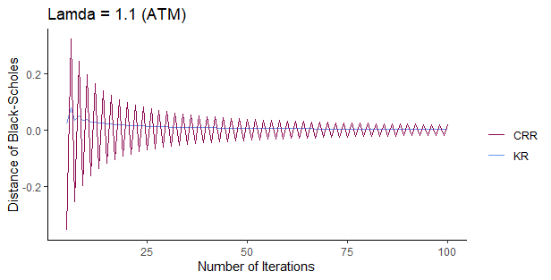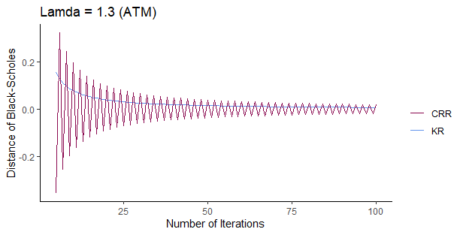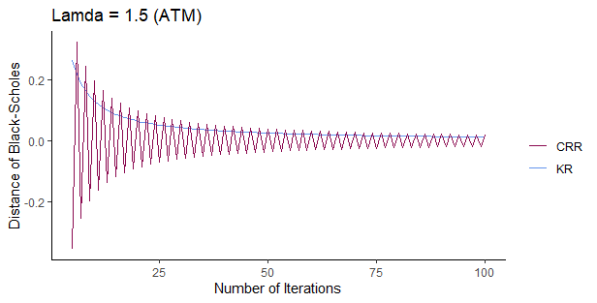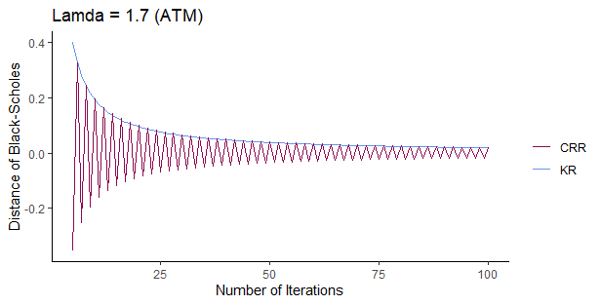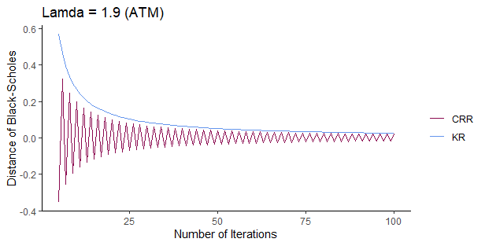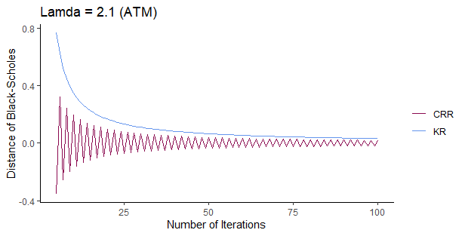

IN THE MONEY

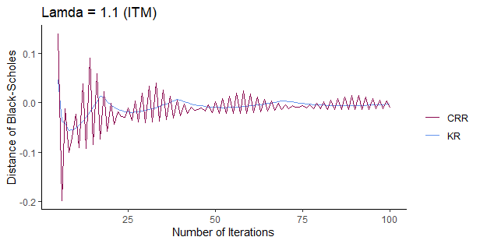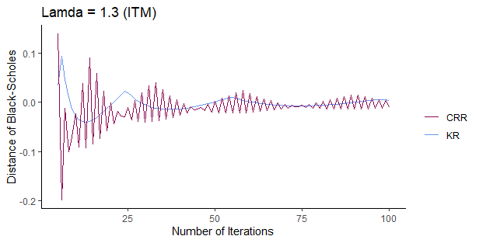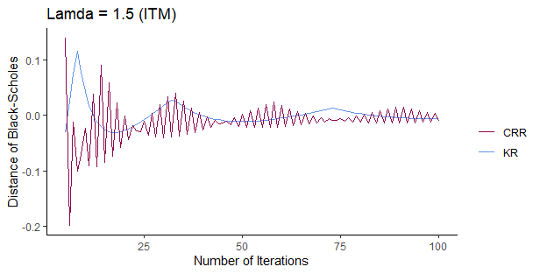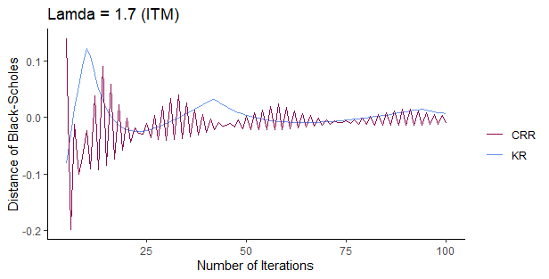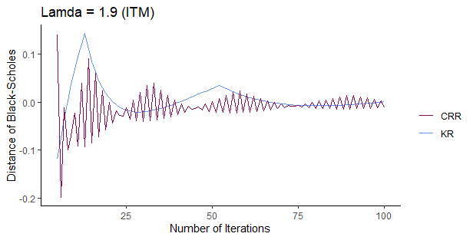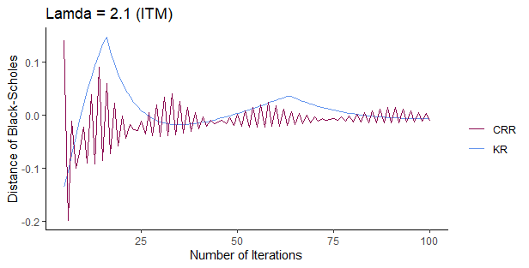

OUT THE MONEY

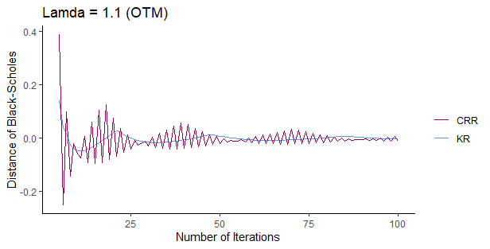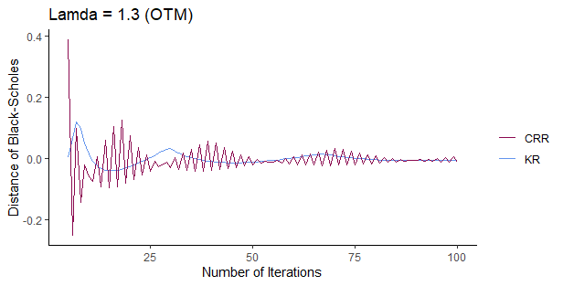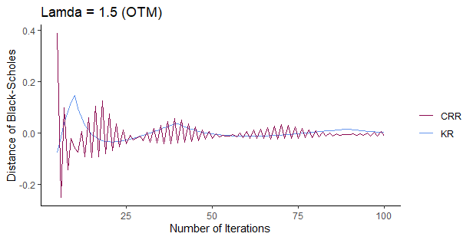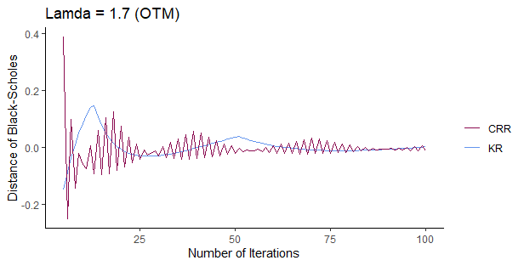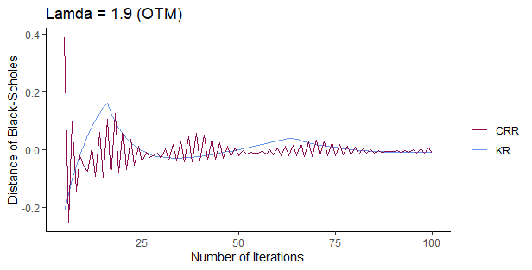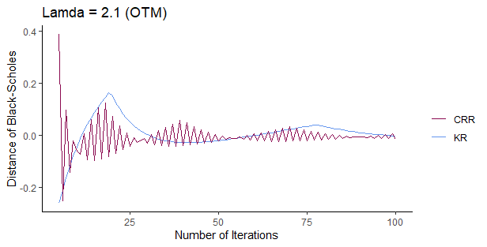

VOLATILITY ANALYSIS
S₀ = 100 | K = 100 | Risk Free = 0.05 | Lamda = 1.22474 | Time = 1
Number of iterations | CRR | KR | DiffCRR | DiffKR
 |  | Sigma = 0.15 | BS = 8,5917
5 | 8,8380 | 8,4831 | -0,2464 | 0,1086
10 | 8,4406 | 8,5356 | 0,1510 | 0,0560
20 | 8,5156 | 8,5633 | 0,0761 | 0,0283
40 | 8,5535 | 8,5774 | 0,0382 | 0,0142
60 | 8,5662 | 8,5821 | 0,0255 | 0,0095
80 | 8,5725 | 8,5845 | 0,0191 | 0,0071
100 | 8,5764 | 8,5859 | 0,0153 | 0,0057
 |  | Sigma = 0.18 | BS = 9,7023
5 | 10,0149 | 9,5884 | -0,3126 | 0,1139
10 | 9,5237 | 9,6431 | 0,1786 | 0,0592
20 | 9,6123 | 9,6723 | 0,0900 | 0,0300
40 | 9,6572 | 9,6872 | 0,0452 | 0,0151
60 | 9,6722 | 9,6922 | 0,0301 | 0,0101
80 | 9,6797 | 9,6948 | 0,0226 | 0,0076
100 | 9,6842 | 9,6963 | 0,0181 | 0,0061
 |  | Sigma = 0.24 | BS = 11,9578
5 | 12,3961 | 11,8279 | -0,4383 | 0,1299
10 | 11,7234 | 11,8897 | 0,2344 | 0,0681
20 | 11,8397 | 11,9231 | 0,1181 | 0,0346
40 | 11,8985 | 11,9403 | 0,0592 | 0,0175
60 | 11,9182 | 11,9461 | 0,0395 | 0,0117
80 | 11,9281 | 11,9490 | 0,0297 | 0,0088
100 | 11,9340 | 11,9508 | 0,0237 | 0,0070

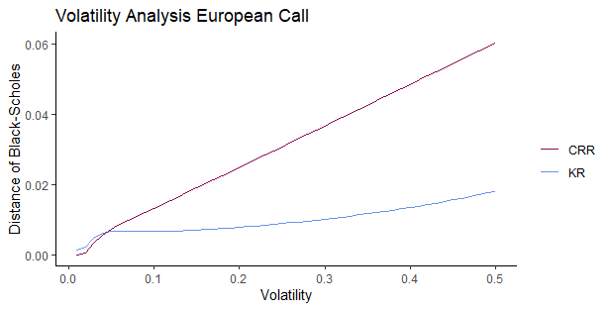

RISK FREE ANALYSIS
S₀ = 100 | K = 100 | Sigma = 0.02 | Lamda = 1.22474 | Time = 1
Number of iterations | CRR | KR | DiffCRR | DiffKR
 |  | Risk free = 0.01 | BS = 8,4333
5 | 8,8327 | 8,3416 | -0,3994 | 0,0917
10 | 8,2377 | 8,3847 | 0,1956 | 0,0487
20 | 8,3348 | 8,4085 | 0,0985 | 0,0248
40 | 8,3839 | 8,4208 | 0,0494 | 0,0125
60 | 8,4003 | 8,4249 | 0,0330 | 0,0084
80 | 8,4086 | 8,4270 | 0,0248 | 0,0063
100 | 8,4135 | 8,4283 | 0,0198 | 0,0050
 |  | Risk free = 0.04 | BS = 9,9251
5 | 10,2956 | 9,8184 | -0,3706 | 0,1066
10 | 9,7289 | 9,8691 | 0,1962 | 0,0560
20 | 9,8262 | 9,8966 | 0,0988 | 0,0285
40 | 9,8755 | 9,9107 | 0,0496 | 0,0144
60 | 9,8920 | 9,9155 | 0,0331 | 0,0096
80 | 9,9002 | 9,9178 | 0,0248 | 0,0072
100 | 9,9052 | 9,9193 | 0,0199 | 0,0058
 |  | Risk free = 0.07 | BS = 11,5415
5 | 11,8590 | 11,3891 | -0,3175 | 0,1524
10 | 11,3414 | 11,4630 | 0,2001 | 0,0785
20 | 11,4407 | 11,5018 | 0,1008 | 0,0397
40 | 11,4909 | 11,5215 | 0,0506 | 0,0199
60 | 11,5077 | 11,5282 | 0,0338 | 0,0133
80 | 11,5161 | 11,5315 | 0,0253 | 0,0100
100 | 11,5212 | 11,5335 | 0,0203 | 0,0080

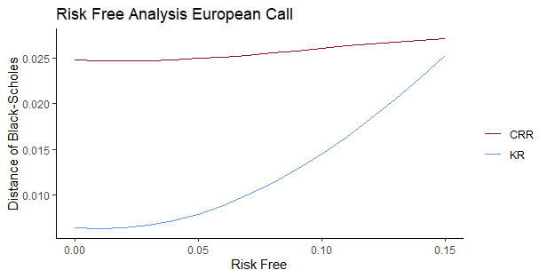

TIME ANALYSIS
S₀ = 100 | K = 100 | Sigma = 0.02 | Lamda = 1.22474 | Risk free = 0.05
Number of iterations | CRR | KR | DiffCRR | DiffKR
 |  | Time = 2/12 | BS = 3,6747
5 | 3,8370 | 3,6365 | -0,1623 | 0,0382
10 | 3,5944 | 3,6545 | 0,0804 | 0,0203
20 | 3,6343 | 3,6644 | 0,0405 | 0,0103
40 | 3,6544 | 3,6695 | 0,0203 | 0,0052
60 | 3,6612 | 3,6712 | 0,0136 | 0,0035
80 | 3,6646 | 3,6721 | 0,0102 | 0,0026
100 | 3,6666 | 3,6726 | 0,0081 | 0,0021
 |  | Time = 5/12 | BS = 6,1907
5 | 6,4389 | 6,1259 | -0,2482 | 0,0648
10 | 6,0635 | 6,1565 | 0,1272 | 0,0341
20 | 6,1266 | 6,1733 | 0,0641 | 0,0174
40 | 6,1585 | 6,1819 | 0,0321 | 0,0088
60 | 6,1692 | 6,1848 | 0,0214 | 0,0059
80 | 6,1746 | 6,1863 | 0,0161 | 0,0044
100 | 6,1778 | 6,1871 | 0,0129 | 0,0035
 |  | Time = 8/12 | BS = 8,1726
5 | 8,4762 | 8,0846 | -0,3036 | 0,0880
10 | 8,0116 | 8,1264 | 0,1609 | 0,0462
20 | 8,0915 | 8,1491 | 0,0811 | 0,0235
40 | 8,1319 | 8,1607 | 0,0407 | 0,0118
60 | 8,1454 | 8,1647 | 0,0271 | 0,0079
80 | 8,1522 | 8,1666 | 0,0204 | 0,0059
100 | 8,1563 | 8,1678 | 0,0163 | 0,0048

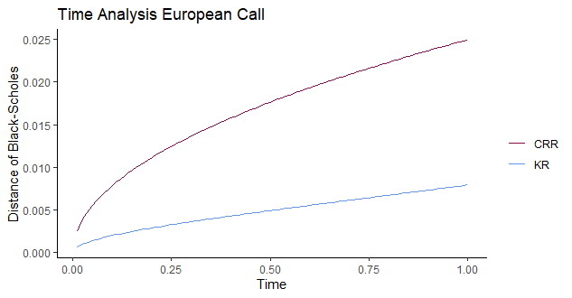

PROBABILITY ANALYSIS
 | 1 | 1.1 | 1.22474 | 1.4 | 1.7 | 1.9 | 2.1
Prob.1 | 0,50839 | 0,42085 | 0,34018 | 0,26109 | 0,17794 | 0,14292 | 0,11737
Prob.2 | 0,49161 | 0,40560 | 0,32648 | 0,24911 | 0,16808 | 0,13409 | 0,10939
Prob.3 | 0,00000 | 0,17355 | 0,33332 | 0,48980 | 0,65398 | 0,72299 | 0,77324

